Java Script :

**TOPIC 1 : JS FUNCTIONS**

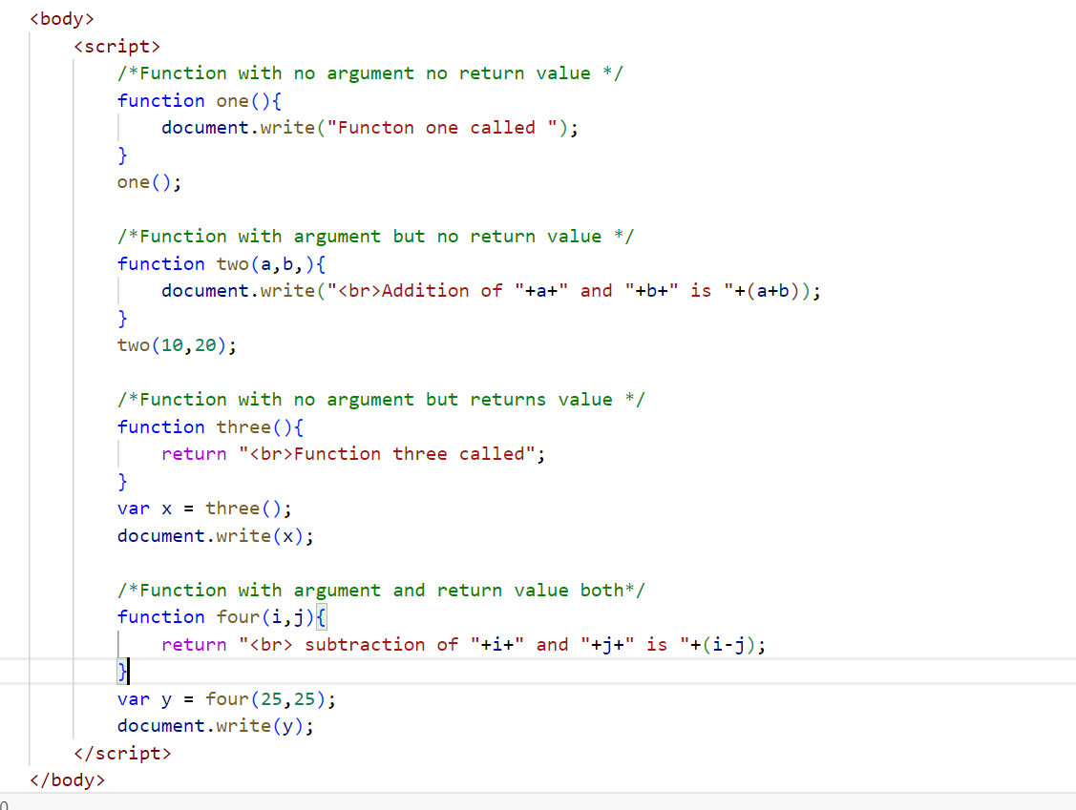

OUTPUT :

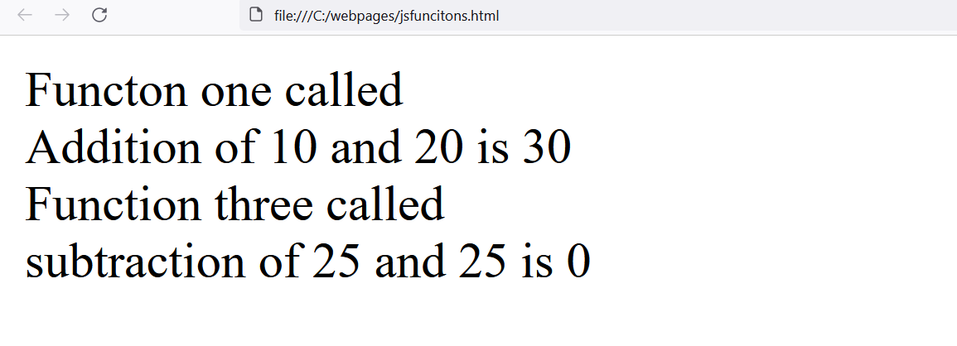

TOPIC 2 : ARROW FUNCTION ES6

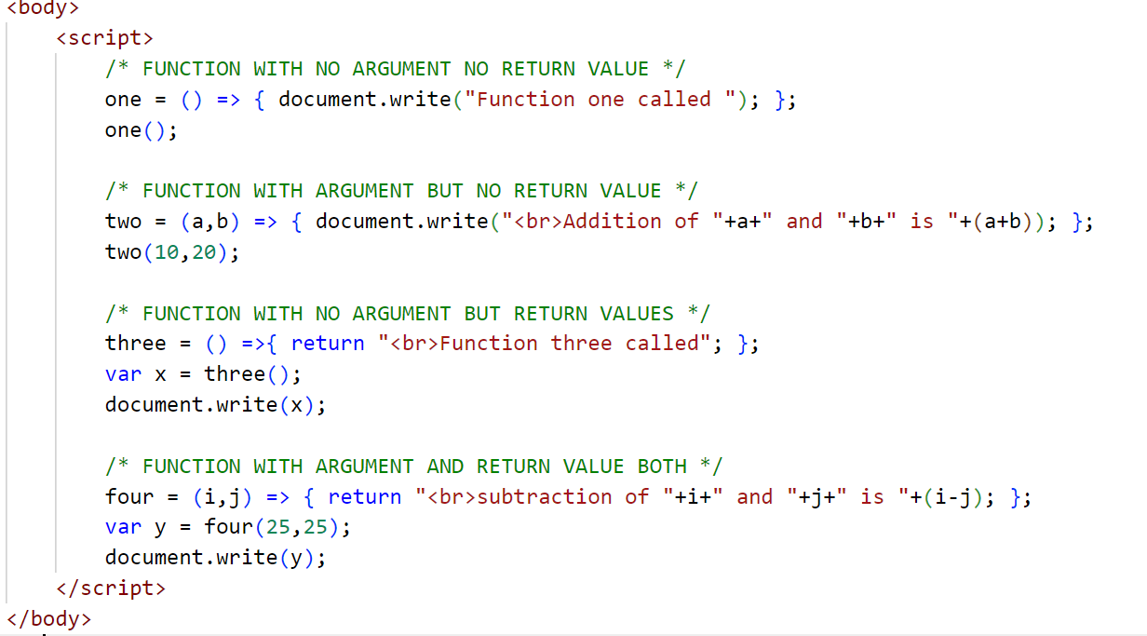

OUTPUT :

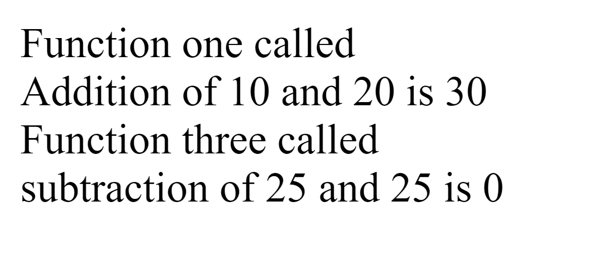

**TOPIC 3 : CALLING FUNCTION IN DIFFERENT SCENARIO**

1. **CALLING FUNCTION ON BUTTON CLICK**
2. **CALLING FUNCTION BASED ON CONDITION**

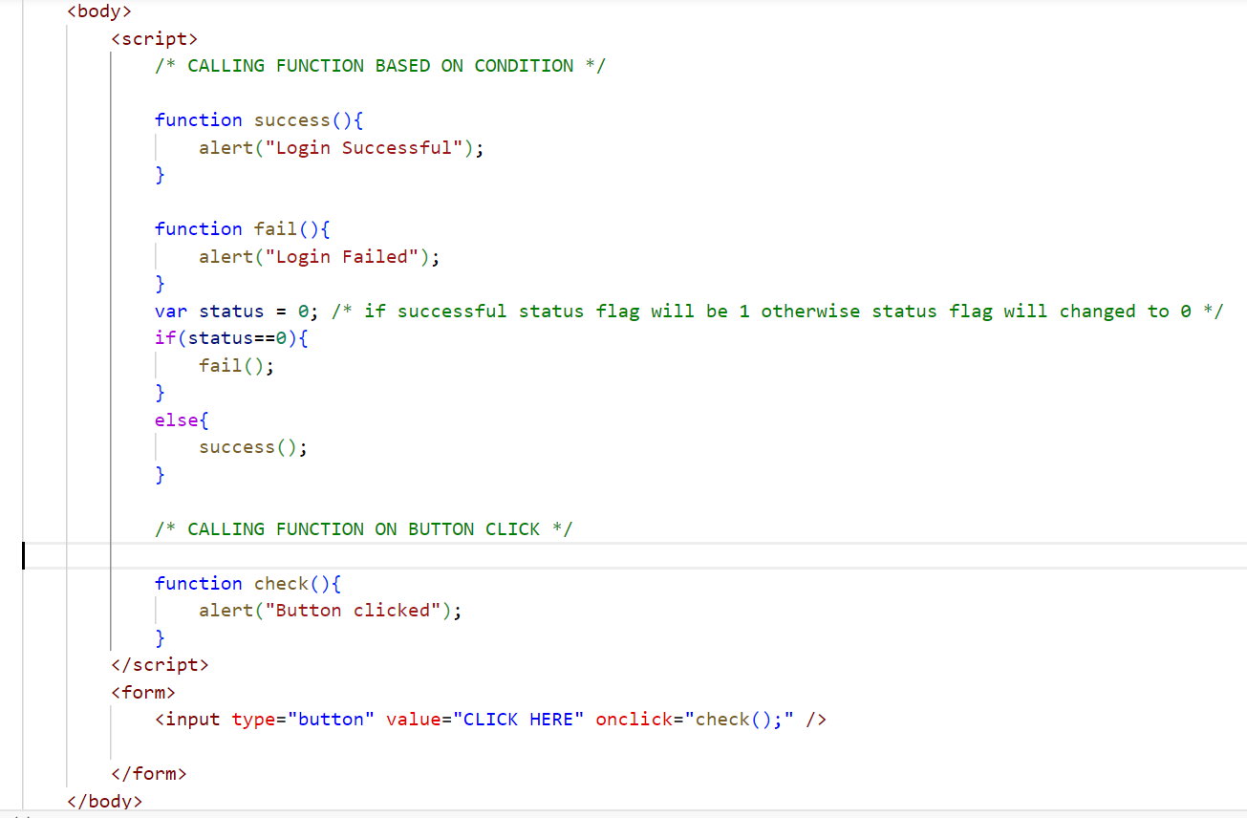

OUTPUT :



**TOPIC 4 : PASSING FORM DATA TO JS FUNCTION**

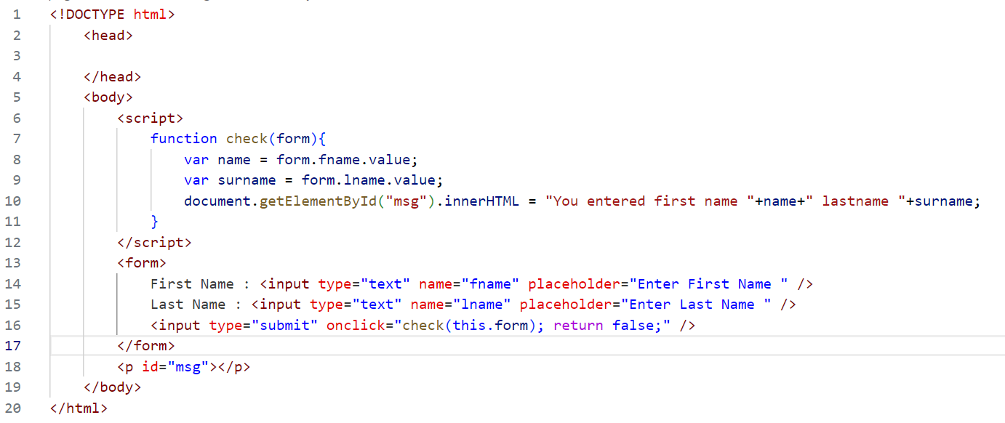

OUTPUT

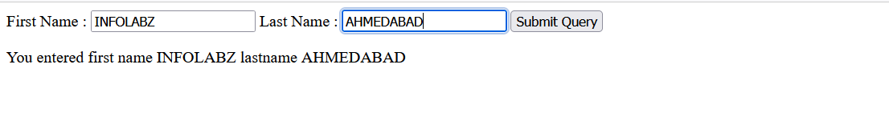

EXERCISE 1 : LOGIN FORM

CONDITION : IF USER ENTERS EMAIL = a@b.com and password = abc123 print

**LOGIN SUCCESSFUL** OTHERWISE PRINT **INVALID USERNAME OR PASSWORD**

OUTPUT :

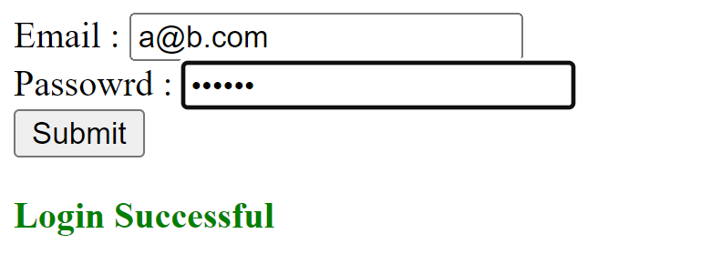

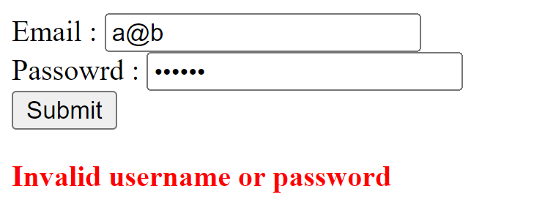

EXERCISE 2 : APPLY VALIDATION IN ABOVE CODE

1. EMAIL CAN NOT BE BLANK
2. PASSWORD CAN NOT BE BLANK
3. BOTH FIELDS ARE REQUIRED
4. LOGIN SUCCESSFUL ( if email=a@b.com and password = abc123 )
5. INVALID USERNAME OR PASSWORD( for rest of the data )

EXERCISE 3 : FORM TO TABLE

CREATE A FORM WITH FOLLOWING FIELDS

NAME ( TEXT BOX )

EMAIL ( EMAIL FIELD )

PASSWORD ( PASSWORD FIELD )

RETYPE PASSWORD ( PASSWORD FIELD )

GENDER ( RADIO BUTTON )

CITY ( DROP DOWN )

ADDRESS ( TEXTAREA )

AGREE TO TERMS AND CONDITIONS ( CHECKBOX )

ON BUTTON CLICK PRINT ALL THE DATA IN HTML TABLE

CHECK FOLLOWING CONDITION :

1. IF CHECKBOX NOT CHECKED PRINT PLEASE AGREE TO TERMS AND CONDITIONS
2. IF PASSWORD AND RETYPE PASSWORD IS NOT SAME PRINT PASSWORD AND RETYPE PASSWORD MUST BE SAME